Criminal Laws and Their Sources
When a society and its government decide that certain conduct is dangerous to citizens or damaging to the society as a whole, such conduct is labeled a "crime" and is made punishable by sanctions such as fines and imprisonment. People who violate a criminal law can be punished through fines, imprisonment, probation and community service.
The criminal law encompasses the entire criminal process itself – from investigation and arrest, to conviction and sentencing – and the people who play a role in that process: the accused, police officers, prosecuting attorneys, criminal defense attorneys, judges, witnesses and probation officers. The outcome of criminal case depends upon the crime charged, the strength of the evidence and the goals and strategy of the government and defense. Some potential outcomes of a criminal case are: a criminal investigation ends with no arrest; an arrest occurs, but the case is dismissed because the police illegally seized the only evidence of crime; a person is arrested and charged with a crime, then enters into a plea bargain with the government, agreeing to plead "guilty" in exchange for some form of leniency, such as a lighter sentence; a person is brought to trial and found "not guilty," or acquitted, by a jury; a person is convicted by a jury and sentenced to a shorter or longer prison term.
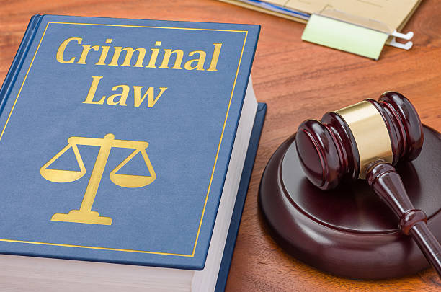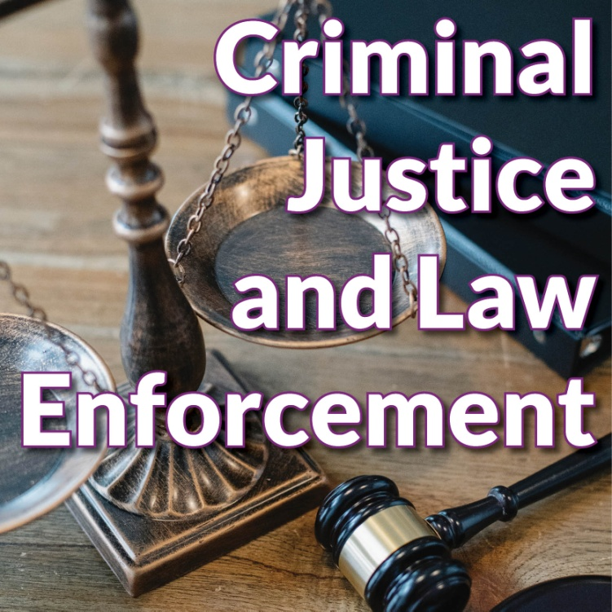
Vocabulary
conduct – behaviour
to be labeled – to be marked
fine (noun) – an amount of money that has to be paid as a punishment for not obeying a rule or law
to violate a criminal law – to break or fail to comply with (a rule)
probation – the release of an offender from detention, subject to a period of good behaviour under supervision
community service – unpaid work, , intended to be of social use, that an offender is required to to do instead of going to prison
to encompass – to surround and have or hold within
conviction – the decision of a judge in a court of law that someone is guilty of a criminal offence
sentencing – declare the punishment decided (for an offender)
the accused – charged with a crime or offense in a court of law
prosecuting attorney – an attorney who conducts proceedings in a court on behalf of the government
criminal defense attorney – an attorney representing a defendent in a lawsuit or criminal prosecution
probation officer – an officer appointed to supervise the conduct of convicted offender on probation
to be charged with a crime – a formal allegation (a statement not yet proven) of an offense is made
the case is dismissed – there is no need for a trial, usually because there is not enough evidence for the case to continue
to seize evidence – to take by legal process or force
plea bargain – an agreement that , if an accused person says they are guilty, they will be charged with a less serious crime or will receive a less severe punishment
leniency – treatment in which someone is punished or judged less strongly or severely than would be expected
to be acquitted – to be free from a criminal charge by a verdict of “ not guilty“

CRIMINAL LAWS AND THEIR SOURCES
1 When a society and its government decide that certain ___ is dangerous, it is labeled a crime.
A conductor
B conducive
C connectives
D conduct

2 A crime is something dangerous to citizens or damaging to the ___ as a whole.
A social
B socialism
C society
D socially

3 A crime is then made punishable by ___ such as fines and imprisonment.
A sanctions
B sanction
C sanctuary
D sanitary

4 People who ___ a criminal law can be punished through fines.
A villain
B violation
C violate
D verdict

5 Such people can also be punished through ___ .
A imprisonment
B prisons
C impersonal
D refinement

6 The criminal law encompasses the entire ___ process itself.
A crime
B criminal
C crimes
D police

7 Sometimes a person ___ to trial only to be found not guilty by a jury.
A speaks
B is brought
C brings
D bringing

8 One potential ___ of a criminal case is that a criminal investigation ends with no arrest.
A advantage
B outcome
C disadvantage
D proceeding

9 Sometimes a person can enter into a ___ bargain with the government.
A pleasant
B plea
C plentiful
D plurality

10 A person can agree to plead guilty in exchange for a ___ sentence, for instance.
A lonely
B easier
C better
D lighter

